89th Annual

WISCONSIN MOOSE BOWLING TOURNAMENT

USBC Moral Support Sanctioned
RiversEdge Bowl
215 S River St
Janesville, WI 53545
608-756-1201
+-0400

2024
March 9 through April 14
Entries close February 9, 2024
For Office Use
B

OPEN TO MEMBERS in good standing of Wisconsin Moose Lodges and to members in good standing of other Moose Lodges who have established residency in Wisconsin at least six months prior to bowling in the tournament.

Team Name Captain Email
1 Squad per Saturday 12 pm Start Time

Schedule books will be handed out at mid-year conference. One book per team.

$80.00

Tentative Squad Time
(Max 48 bowlers
per squad)
4 PERSON TEAM Sunday 1 Squad per Sunday 10:00 am Start time Max 12 teams per Squad

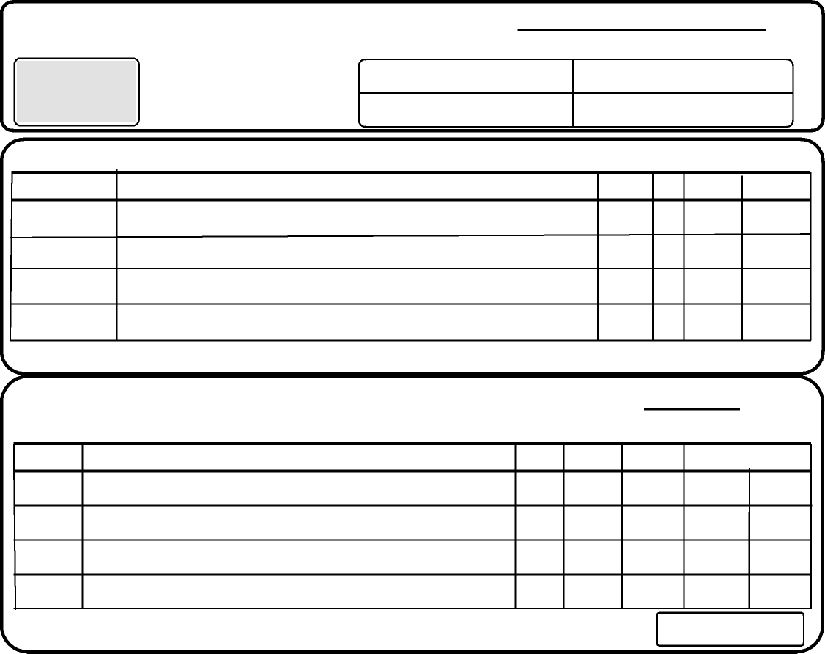
First Choice Second Choice

Team Event
Singles and Doubles
$
*See Rule 1 - 4 on reverse side. All Entries must have full team fee. Total per Team
USBC  Sanction Card Number PRINT FULL NAME (Order of Lineup) | Ave. | No Ave. | Last Tourn. Average | Total
 |  |  |  | $20.00
 |  |  |  | $20.00
 |  |  |  | $20.00
 |  |  |  | $20.00

USBC  Sanction Card | PRINT FULL NAME (Order of Lineup) | Ave. | Singles | Doubles | All Events TOTAL  Optional
 | 1
 | 2
 | 1
 | 2

SINGLES & DOUBLES
Total amount submitted per this form (include team fee)
Please indicate Team Status, also Bowling Dates and Times preferred below. (MUST HAVE 2 DIFFERENT CHOICES)
I hereby certify the above entrants are members of our Lodge, Co-workers of our Chapter or are wives of members of our Lodge and their averages are correct as stated in entering rule.
ENTRIES NOT VALID UNLESS ACCOMPANIED BY FULL AMOUNT OF TOURNAMENT FEES AND LINE UP OF BOWLERS
Date: Signed by: ___________________________________ Lodge Name & # ___________________
Send all entries to Bowling Chairman Wisconsin Moose Association • Margie Marsden • 1259 Ruger Ave, Janesville, WI 53545 • (608) 289-5752 • Email: warmmd@yahoo.com
89th Annual
2024
WISCONSIN MOOSE BOWLING TOURNAMENT
USBC Moral Support Sanctioned

HOST LODGE:  Janesville #197  418 W Milwaukee St  Janesville, WI  608-752-0809 | Schedule  March 9/10, 16/17, 22/23,  April 6/7, 2024 | SCHEDULE:  February 28th through April 12th 2015  Except March 14th & 15th and  April 4th & 5th (Easter Weekend)

FEES PER ENTRANT
Prize Fund Bowling Expenses Total
Team (4 person) 4.50 12.50 3.00 20.00
Singles 3.50 12.50 3.00 19.00
Doubles 3.50 12.50 3.00 19.00
All Events (Optional) 2.00 N/A N/A 2.00

Cost Per Bowler $11.50 $37.50 $9.00 $60.00
Total Fees Must Accompany Entries
USBC MORAL SUPPORT SANCTION provides high score protection for those with established USBC membership and allows for the participation of those not qualified with the Congress without payment of any dues. Rule 319b.
- Use last year’s highest sanctioned league average (21 games or more).
- If no average last year, use current year’s highest sanctioned league average (21 games or more).
- If no previous average, in any of the above, and bowler participated in last year’s Wisconsin Moose Association
Bowling Tournament (9 games), that average must be used.
- If no established average in any of the above, use 160 for men and 130 for women.
RULES WILL APPLY TO ALL PARTICIPANTS
This tournament is governed by the Rules of the USBC and the Wisconsin Moose Association Bowling Tournament. Bowlers must be registered and present credentials at least 30 minutes before bowling time in each event. Failure to present credentials or failing to appear as scheduled may result in forfeiture of tournament fees, unless arrangements for schedule change has been made with Bowling Chairperson prior to weekend schedule.
HANDICAPS: USBC 90% of the difference between average and 225.
ENTRANTS MAY BOWL ONLY ONCE IN THIS TOURNAMENT EACH EVENT except host lodge participant, which may substitute and qualify as many times as needed in an emergency. The fee for affiliated membership is $22.00 for USBC.
Rule 319e - If during the 12-month period immediately preceding the time and date of bowling, the bowlers accumulated for all, but not less than 21 tournament games, exceeds the average to be used for entry by 15 or more pins. In that case, the accumulated average must be used for handicapping or classification purposes. Averages established in summer leagues will be accepted, provided the bowler does not have an acceptable regular season average. Any bowler who reports a lower average than required at time of bowling, or who fails to report a prize of $300.00 or more in the previous 12 months shall forfeit tournament entry fees and prize winnings. It shall be each bowler’s responsibility to verify the accuracy of their average, whether originally submitted by the bowler, the team captain or others. Failure to use proper average or make a correction up to completion of the first game or participation shall disqualify score if submitted average is lower than actual average. Prize winnings shall be based on the submitted average if it is higher than actual average. Any bowler whose average has been re-rated by their local association, must use their re-rated average in this tournament. All entrants must be familiar with and abide by USBC Rule on re-rating requirements.
USBC AVERAGES from bowl.com will be used.
ALL PRIZE FEES WILL BE RETURNED 100% - Prize ratio is 1 - 10 each event • 1 - 15 all events.
20% of good bowling prize fund in each event paid for scratch prizes.
REFUND POLICY - Full refund 30 days prior to bowling. If less than 30 days, NO refund unless due to sickness or death.
WISCONSIN STATE BOWLING CHAIRMAN: Margie Marsden, Bowling Chairman • 1259 Ruger Ave, Janesville, WI 53545 • (608) 289-5752

For reserved dates, remittances must be made payable to WISCONSIN MOOSE BOWLING TOURNAMENT and mailed prior to midnight December 31st, 2023. After December 31st it will be first postmarked - first scheduled, according to availability. Entries close February 9, 2024.

